You are given two lists of closed intervals, firstList and secondList, where firstList[i] = [starti, endi] and secondList[j] = [startj, endj]. Each list of intervals is pairwise **disjoint** and in **sorted order**.

Return *the intersection of these two interval lists*.

A **closed interval** [a, b] (with a <= b) denotes the set of real numbers x with a <= x <= b.

The **intersection** of two closed intervals is a set of real numbers that are either empty or represented as a closed interval. For example, the intersection of [1, 3] and [2, 4] is [2, 3].

**Example 1:**

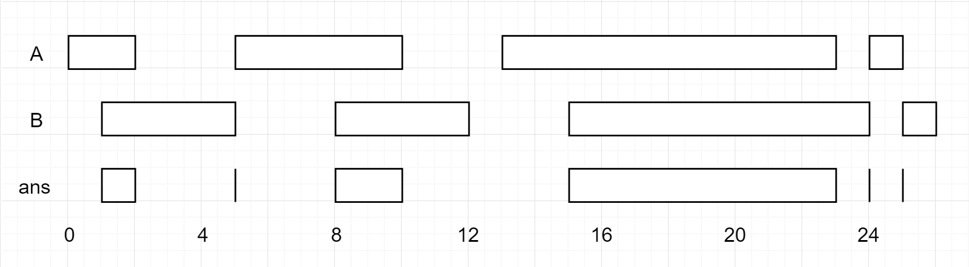

Input: firstList = [[0,2],[5,10],[13,23],[24,25]], secondList = [[1,5],[8,12],[15,24],[25,26]]  
Output: [[1,2],[5,5],[8,10],[15,23],[24,24],[25,25]]

**Example 2:**

Input: firstList = [[1,3],[5,9]], secondList = []  
Output: []

**Constraints:**

* 0 <= firstList.length, secondList.length <= 1000
* firstList.length + secondList.length >= 1
* 0 <= starti < endi <= 109
* endi < starti+1
* 0 <= startj < endj <= 109
* endj < startj+1